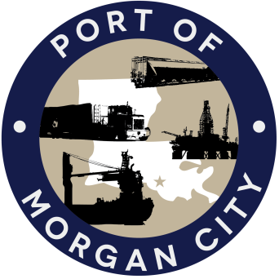
MORGAN CITY HARBOR AND TERMINAL DISTRICT
7327 Highway 182 . P. O. Box 1460 . Morgan City, LA 70381
TELEPHONE (985) 384-0850 . FAX (985) 385-1931
Email: office@portofmc.com . www.portofmc.com

March 27, 2026

Major General Kimberly Peeples
Mississippi River Commission Members

Dear Major General Peeples and Members of the Mississippi River Commission:

Thank you once again for the opportunity to update you on the success we are experiencing in the Port of Morgan City area. Innovative dredging techniques and increased operations and maintenance funding are consistently providing a reliable, navigable Atchafalaya River and Bayous Chene, Boeuf, and Black (ARBCBB) 20 foot deep by 400 foot wide federally authorized project.

As always, the Port of Morgan City board members and staff would like to express our appreciation for the support we have received from members of the Mississippi River Commission; USACE New Orleans, Vicksburg, and Headquarters; the Assistant Secretary of the Army; the Office of Management and Budget; House & Senate Energy & Water Appropriations Committees, and our federal delegation which allows Brice Civil Constructors to continue to operate the Dredge Arulaq successfully in the Atchafalaya Bar Channel (ABC).

Unlike a high-tonnage commodities port, billions of dollars in activity produced by recycling/scrap yards, shipyards and fabrication yards that support the U. S. Government and energy production, including the LNG industry located at the Port of Morgan City should not be overlooked or understated. High value industry projects including a variety of energy, aerospace, national defense and U. S. government contracts, including Corps of Engineers dredges, barges and vessels are creating jobs and providing a significant return on our nation’s investment. (Industry photos are attached to this letter.)

The following statement was made by Brandon Mabile, Corporate Business Development Director for Performance Contractors, which is fabricating modules for Venture Global in Plaquemines Parish, LA and has also been awarded LNG work in Calcasieu Parish, LA. Brandon spoke to the Atchafalaya Intracoastal Coalition at their March 9th business luncheon in Morgan City. “Morgan City is so great to come and do business.” “You have a great port here. You have deep water, access to the Atchafalaya, access to the Intracoastal.” “There’s very few places in the state that you can build 3,000-ton modules, get them on barges, and get them out to the Gulf. Morgan City is one of the few.” Brandon’s words are testimony as to what operating the Arulaq in the Atchafalaya Bar Channel and consistent maintenance of the navigation channel is doing for the Port of Morgan City community and our nation.

Major General Kimberly Peeples Page Two
Mississippi River Commission Members March 27, 2025

According to Corps spokesperson, Ricky Boyett, earlier this year, Congress appropriated another $5 million for the Lower Mississippi River (LMR) Comprehensive Management Study, and the Corps will resume work as soon as funds are received. While continued support for the ARBCBB will protect the investments made in this area by industry and state and federal governments, please be reminded that decisions made as a part of the (LMR) Comprehensive Management Study should be decisions that will continue to protect these investments and continue to ensure economic security and safety for our nation. We are aware that decisions may be considered that deviate from the 70/30 split at the Old River Control Structure which we believe could become detrimental to the Morgan City area. The following are some concerns:

- During extended or excessive high water, exceeding the 30% flow could further exacerbate navigation issues on the Atchafalaya River above Morgan City, the Berwick Bay Harbor area and the ARBCBB. Excessive, prolonged high water already causes shoaling at Stouts Pass, Berwick Bay Harbor, and Tidewater Point in a U. S. Coast Guard heavily regulated area and requires many navigation restrictions. We must stress that any changes that will send additional water or sediment will require more navigation restrictions and additional maintenance in an area where additional MR&T funding through this critical waterway intersection is already crucial.

- During high water, commerce on Bayou Chene in the POMC District is disrupted as well. As long as high-water levels remain on the Atchafalaya River, the Bayou Chene Flood Control structure remains closed to navigation and prevents the delivery of high-value projects to the Gulf of America. Any deviation from the 70/30 split that sends more water down the Atchafalaya River will cause the Bayou Chene Flood Control Structure to remain closed even longer.

Recognizing that appropriate management of the sediment and water within the Atchafalaya River System is critical, the Port of Morgan City supports studies/projects that look at utilizing sediment from the Atchafalaya Basin and the Atchafalaya River for beneficial use in the Terrebonne Basin as a means to improve navigation and recreation, reduce flooding, and protect Terrebonne and surrounding parishes from hurricanes.

As always, we are grateful for your time, attention and support.

Sincerely,

Raymond “Mac” Wade
Executive Director

Major General Kimberly Peeples Page Three
Mississippi River Commission Members March 27, 2025

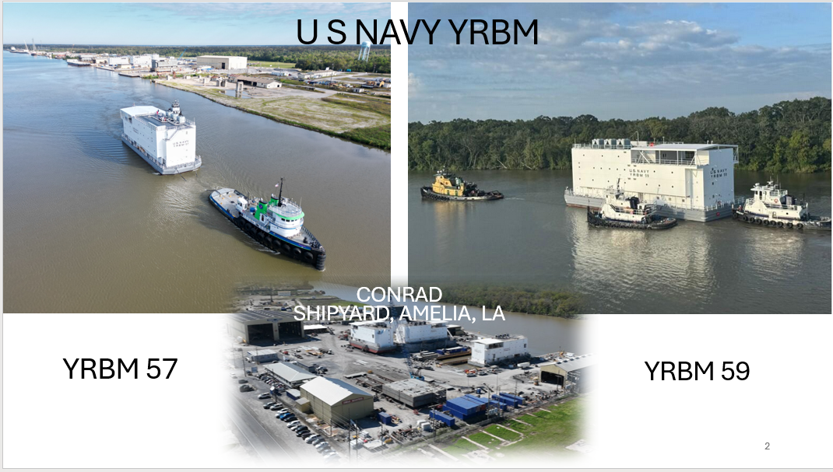

The U.S. Navy has awarded a series of 11 new yard, repair, berthing, and messing (YRBM) barges. ACCOMMODATION BARGES
4 have been delivered, and number 5 and 6 are scheduled for delivery this summer.
The first 3 went to San Diego, Japan, and Guam.

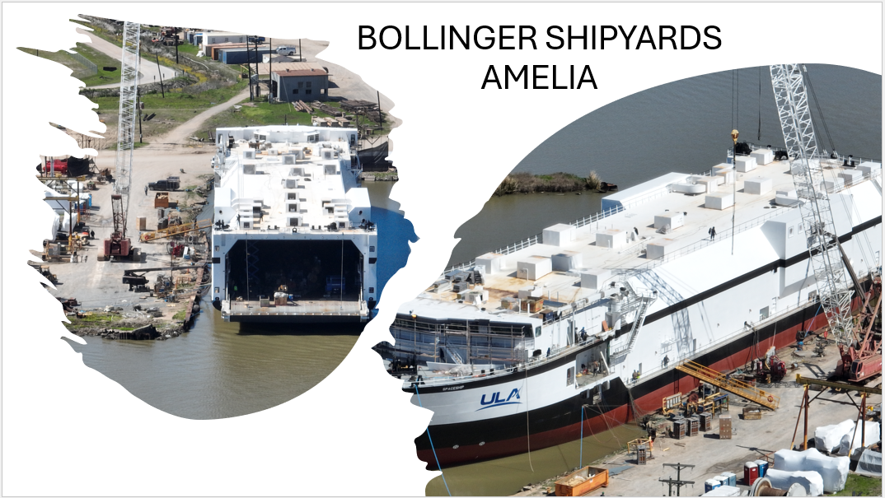

SpaceShip, the second rocket transport vessel for United Launch Alliance LLC (ULA), Centennial, Col., is nearing completion at Bollinger Shipyards' facility in Amelia, La.

Major General Kimberly Peeples Page Four
Mississippi River Commission Members March 27, 2025

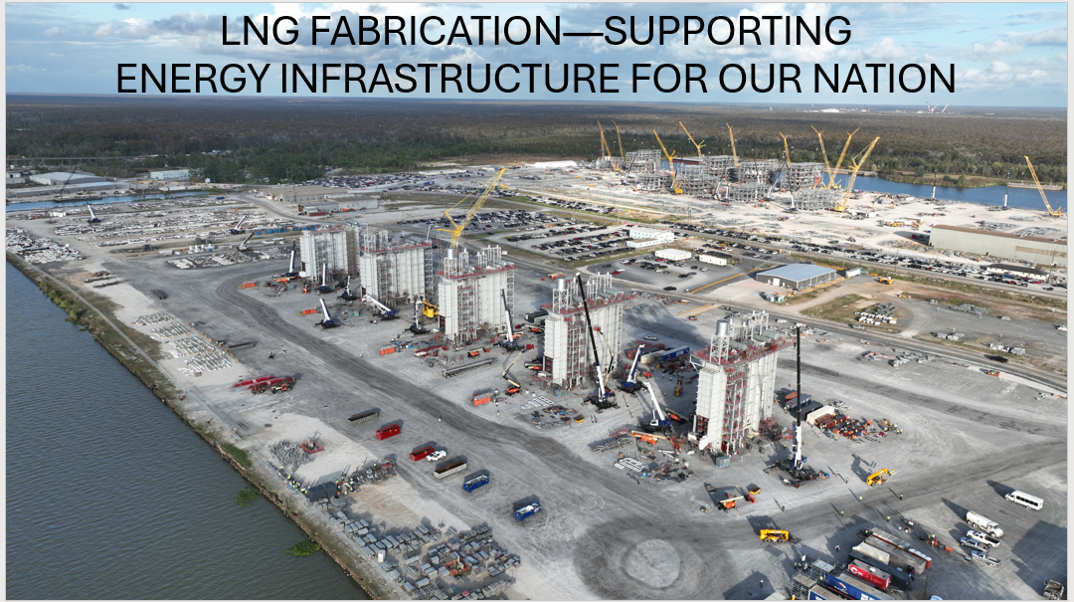

MORGAN CITY MODULE YARD-2,300 EMPLOYEES ON SITE

Built to Date:
14 Process Modules (Avg 3,200T)
35,000 tons of steel
525,000 feet linear pipe
650 pieces of process equipment

In Process:
14 Process Modules
5 HRSG Modules

