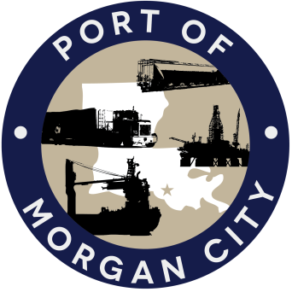

AGENDA

MORGAN CITY HARBOR AND TERMINAL DISTRICT
Regular Meeting of January 11, 2016 – 5:00 p.m. - 800 Youngs Road

- Call to Order

- Roll Call

- Invocation

- Pledge of Allegiance

- Minutes

Regular Meeting of December 14, 2015

- Finance Report
A. Presentation and discussion of financial reports for December 2015 – Deborah Garber
B. Invoices

Guest(s)
A. United States Coast Guard
B. Corps of Engineers, New Orleans District

Raymond “Mac” Wade - Executive Director’s Report

A. Consultant – Jonathan Hird, Moffatt & Nichol
B. Consultant – Michael Knobloch, Knobloch Professional Services, LLC
C. Consultant – Clay Breaud, Providence/GSE
D. Consultants –Carl Blum, Architect
E. Cindy Cutrera, Manager of Economic Development

- Gerard Bourgeois - Legal Report

- New Business
- Discussion and any action on declaration of a state of emergency and authorization of President and Executive Officer to make necessary purchases and take necessary action to prevent loss of live or threats to property.

- Old Business
A. Discussion and any action on leasing, improvements, maintenance and repairs to facility, including Coast Guard lease(s)
B. Discussion and any action regarding the U.S. Department of Homeland Security grant program, including request for proposals, bids, purchases, project management, generators, computer data system and NOAA ports system(s).
C. Discussion and any action on Government Operations and Emergency Center including bids, purchases, project agreements, change orders, inspection, payments, leasing and Facility Planning and Control
D. Discussion and any action on Atchafalaya River Channel dredging and sediment management, including survey services, consulting services and economic study

- Adjournment

In accordance with the Americans with Disabilities Act, if you need special assistance, please contact Tori Henry at 985-384-0850, describing the assistance that is necessary.

